Printed Circuit Boards for the Omega Blade

Christian Coffield

ECEN4013

September 27, 2015

## Introduction

The Omega Blade, comprised of four separate swords, requires a substantial amount of interconnectedness of parts. There are many peripherals that will be attached to each blade, and on top of that, four blades which must connect and communicate with each other. As such there are a variety of electronic components that will be attached. Each of these components will need to be securely fit to the swords. Because the swords will be swung forcefully, the components must be safe and locked into place. Appearance-wise, it is important to not have any exposed circuitry, because it would make the end product look sloppy and incomplete.

Keeping those limitations in mind, the bulk of the electronics would best be placed inside of the sword’s handle. That would include the microcontroller, the speaker and sound board for the Beta Blade, and possibly the accelerometer that will measure swing strength. The point of contention, then, comes from where components that cannot be placed inside of the handle should be placed, and how they should be attached.

There are three options for attaching components along the long length that is required. The first is to simply freely wire the components that can’t fit in the handle into place, and glue them down. The second is to attach as many components as possible to the printed circuit board, and then fabricate smaller boards in key locations. This includes at the base of the guard, where the health indicator would be, the flats of the blade, where colored LEDs light upon swings, and at the tip of the blade, where the IR emitter and potentially the accelerometer would be placed. The final option is to simply have a PCB spanning the length of the blade, however, this option was deemed impossible by reason of cost-- $720 for the set of four boards.

## Single PCB with Hanging Wires

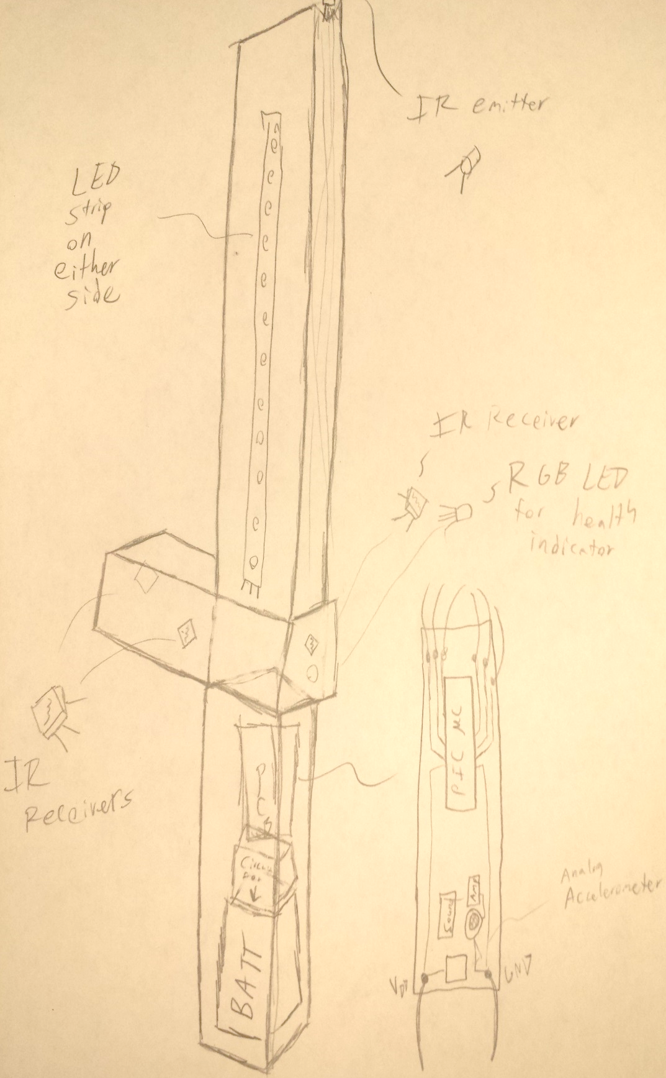

The first option, which involves free-hanging wires on all components that do not fit into the handle, is currently the most viable. Because there are so few components hanging away from the blade, especially with the accelerometer placed in the handle, this option would reduce cost with little to no risk, as all components that are hanging are fairly well isolated. The only two components that would be close to each other and therefore at risk of conflict would be the phototransistor on the back of the guard and the adjacent HP indicator light.

## Central PCB with multiple peripheral PCB’s

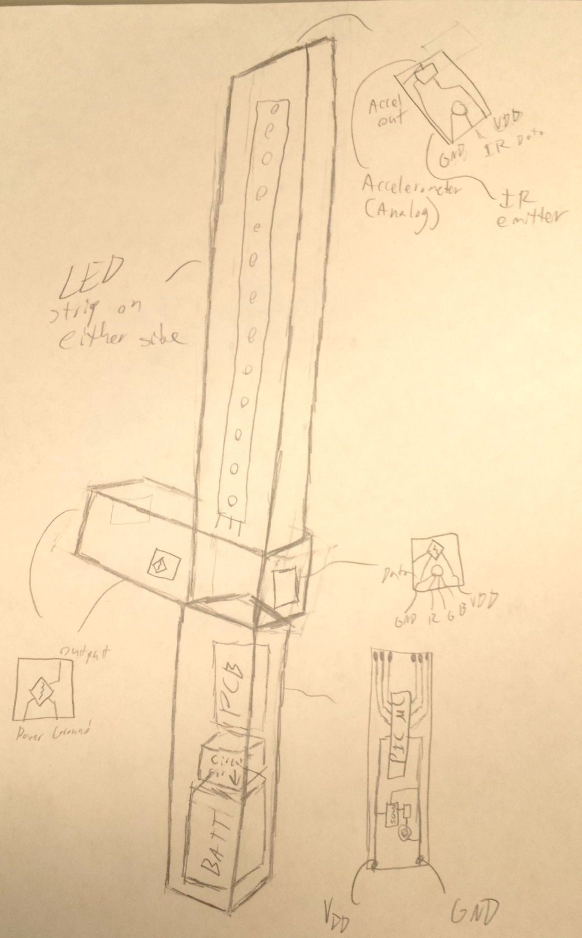

The secondary option would be to have the centralized PCB in the handle, but also place a few sporadically throughout the sword itself. This would place one at the tip that contains the accelerometer and IR emitter, which would allow for a wider range of accelerometer readings with its longer radius from the handle pivot-point. It would also place one at the back of the guard, which would contain the RGB LED for health monitoring and an IR receiver. Potentially, it would also have three very small ones for the remaining three IR receivers.

This method is a little less favorable than the hanging wires, simply because of the significant price jump for having so many PCB’s, multiplied by the number of blades.

## Discussion

Between the two options, free-floating components or piecewise printed circuit boards, the favored option is free-floating. PCBs are a major expense, and to have an additional two or even five per sword, times four swords, would be pricy. The payoff for doing as such is not worthwhile.

There would be a maximum of two components on the piecewise boards, with three of them strictly being one piece; that is not a worthwhile use of boards unless the components absolutely need to have a solid foundation in a board. All of the components planned to be at a distance from the handle’s circuit board can easily be hot-glued into place. They have long legs, which can be soldered to a wire and wrapped in insulation to prevent a short fairly easily. There are no S/PDIP components at a range, so there is no explicit need for a board to place the components on.

There are a few concerns that need to be addressed when handling the circuit components and their placement, however. Because of the incredibly high frequency of the IR transmission (56kHz), crosstalk can cause some serious problems on data reception. Fortunately, all of the IR receivers are close to the handle, which means the length of wire that would have to run to them is relatively short. Texas Instruments’ seminar on high-frequency operating printed circuit boards [3] recommends a few tips to alleviate this problem as well. The straighter the wires and traces are, the less noise there will be, especially on lines that operate at high frequencies. The noise created by the longer ground and power line should not cause any issues with the IR emitter LED, however, because they should not induce enough of a voltage to activate the diode. The LED strips along the sides of the blades are similar, and would not be negatively impacted by the amount of noise by wiring them to the circuit board six to ten inches below.

Because of the cost factor and how easy it would be to free-wire to the long leads of the components that would be at a distance, therefore, the choice to put as many components as possible in the handle and then glue the other components into place, soldering and insulation-wrapping wire around the leads is the most sensible.

Regardless of which method is chosen, however, there are also some considerations that must be accounted for in designing the PCB. Another major choice that will have to be settled on is whether to make the wire connections to the board through-hole or surface-mountable pads. A detailed insight on the benefits and drawbacks to each option can be found in an article by JR Reed [7], but the highlights are space versus reliability. Surface mount joints save much more space compared to through-hole, but their biggest drawback is that they are less durable in high-stress applications. Despite this flaw, the clear winner of the two options is still surface mount, because of how many inputs and outputs each sword will have. There is simply not enough room to have a through-hole for every single component, given the very limited space provided by the hollow handle of the sword. This does provide a new challenge, however. The wires must be connected strongly enough to withstand the occasional jostling or tension. Proposed solutions to this method are to wrap the wires together, so that if one has tension on it, that tension will be distributed across multiple joints and lessen the tug felt by one single solder joint, and to epoxy, glue, or tie the bundle near the PCB so that something less pivotal and flimsy than a solder joint feels the tension before it reaches the board itself.

The other major concern when handling a system with as many components as the Omega Blade is current distribution. Traces in a printed circuit board can only tolerate a certain amount of current passing through them. Jack Olsen of Printed Circuit Design and Fab [4] has a lengthy article that discusses determining the current carrying capacity of a PCB trace, and conversely, how to design a trace to carry a specific amount of minimum current. Once all of the planned components are approved and have their current requirements specified, it is a simple matter of calculating the appropriate widths required to meet them. Traces also must be distanced from each other to isolate noise, but as discussed previously, none of the components planned for the Omega Blade face any noise concerns.

Finally, the board must be secured down to its casing in some fashion. The primary two options for holding it in place are an adhesive and a mechanical fixture. While a mechanical fixture (such as a bolt) would be the most secure for long term holding, it is less bonding, and therefore more prone to vibration. An adhesive may not last as long as a mechanical fixture, or be as strongly robust, but it would provide a stronger protection against vibration. With the already mentioned risk of wire solder joints failing, the best option would be one that removes as much vibration as possible. That makes an adhesive joint more favorable than a mechanical.